Part Number: PT767-35160

Kit Contents

|  |  |  |
| --- | --- | --- |
| Item # | Quantity Reqd. | Description |
| 1 | 2 | Running Boards |
| 2 | 2 | Front Brackets |
| 3 | 4 | Mid/Rear Brackets |
| 4 | 1 | Hardware Bag |

Hardware Bag Contents

|  |  |  |
| --- | --- | --- |
| Item # | Quantity Reqd. | Description |
| 1 | 12 | M6 1.25x19mm Hex Sems Bolt |
| 2 | 12 | M8x1.25x20mm Hex Bolt |
| 3 |  |  |
|  |  |  |

Additional Items Required For Installation

|  |  |  |
| --- | --- | --- |
| Item # | Quantity Reqd. | Description |
| 1 |  |  |
| 2 |  |  |
| 3 |  |  |
|  |  |  |

Conflicts

|  |
| --- |
|  |

Recommended Tools

|  |  |
| --- | --- |
| Personal & Vehicle Protection | Notes |
| Safety Glasses |  |
|  |  |
|  |  |
| Special Tools | Notes |
|  |  |
|  |  |
| Installation Tools | Notes |
| Ratchet | 6” extension |
| 10mm Socket |  |
| 13mm Socket |  |
| Torque Wrench | 0-50 N-m, 0-35 ft-lbf |
| Panel Clip Removal Tool | Panel Pry Tool # 1 Toyota SST  00002-06001-01 |
| Special Chemicals | Notes |
|  |  |
|  |  |
|  |  |

General Applicability

|  |
| --- |
|  |

Recommended Sequence of Application

|  |  |
| --- | --- |
| Item # | Accessory |
| 1 |  |
| 2 |  |
| 3 |  |
|  |  |

\*Mandatory

Vehicle Service Parts (may be required for reassembly)

|  |  |  |
| --- | --- | --- |
| Item # | Quantity Reqd. | Description |
| 1 |  |  |
| 2 |  |  |
| 3 |  |  |
|  |  |  |

Legend

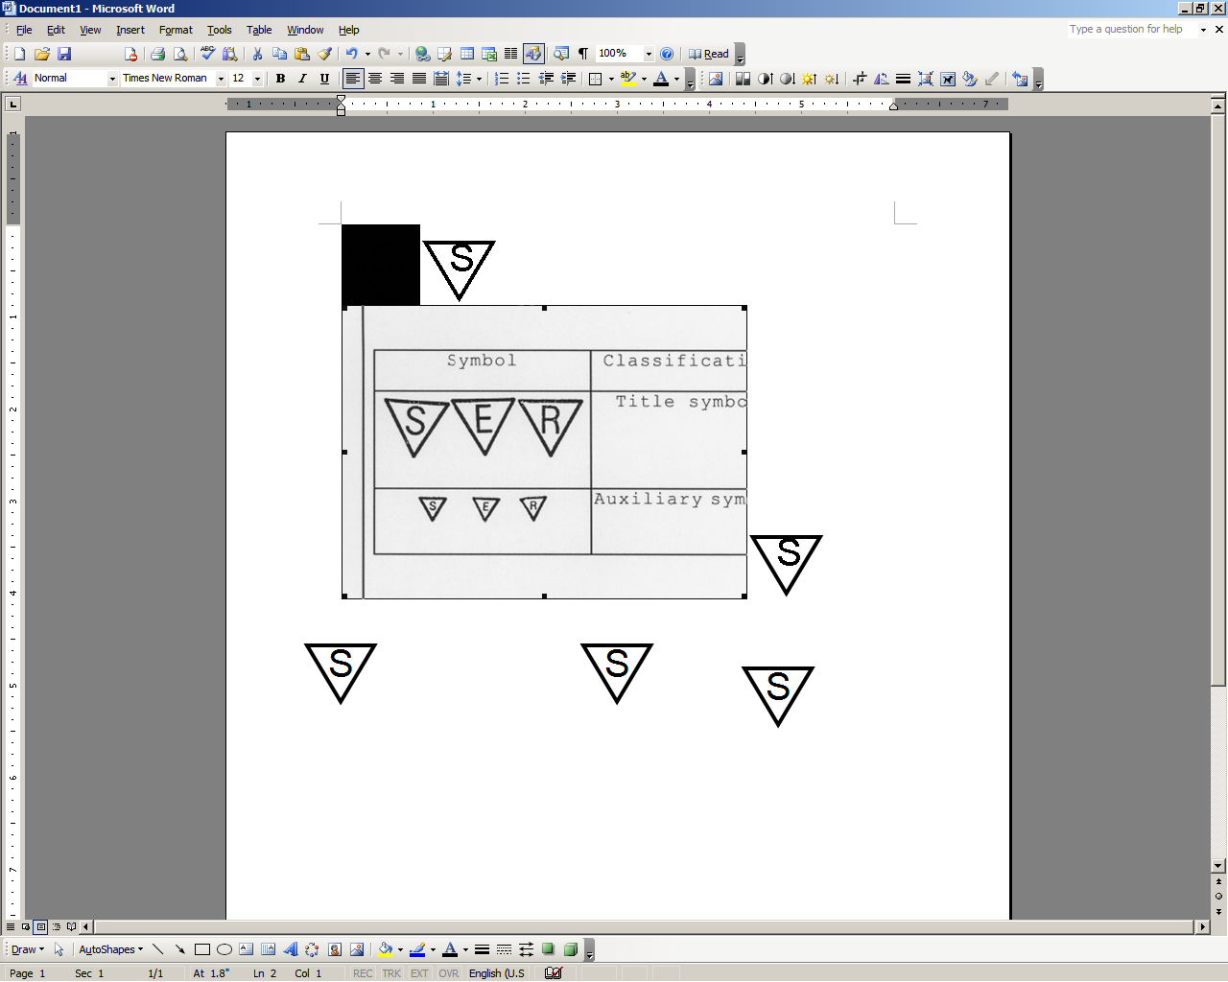

**STOP:** Damage to the vehicle may occur. Do not proceed until process has been complied with.

**OPERATOR SAFETY:** Use caution to avoid risk of injury.

**CAUTION:** A process that must be carefully observed in order to reduce the risk of damage to the accessory/vehicle and to ensure a quality installation.

**TOOLS & EQUIPMENT:** Used in Figures calls out the specific tools and equipment recommended for this process.

**REVISION MARK:** This mark highlights a change in installation with respect to previous issue.  
  
**SAFETY TORQUE:** This mark indicates that torque is related to safety.



Care must be taken when installing this accessory to ensure damage does not occur to the vehicle. The installation of this accessory should follow approved guidelines to ensure a quality installation.

These guidelines can be found in the "Accessory Installation Practices" document.

This document covers such items as:-

* Vehicle Protection (use of covers and blankets, cleaning chemicals, etc.).
* Safety (eye protection, rechecking torque procedure, etc.).
* Vehicle Disassembly/Reassembly (panel removal, part storage, etc.).
* Electrical Component Disassembly/Reassembly (battery disconnection, connector removal, etc.).

Please see your Toyota dealer for a copy of this document.

Install the Left Side Running Board.

* 1. Remove and discard the 6 plastic screws located in the running board mounting holes under the vehicle (Fig. 1-1).



Fig. 1-1

Panel pry tool



* 1. caution_2By hand, place M8 Hex bolts through the holes in the brackets into the threaded holes on the vehicle (Fig. 1-2).

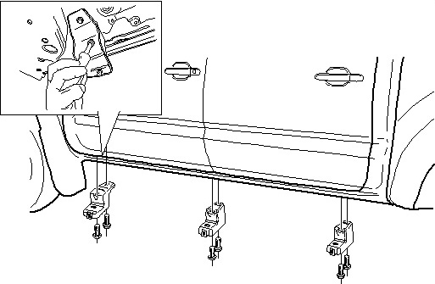

Fig. 1-2

Front

* 1. Place the running board onto the brackets, aligning the front mounting location first (Fig. 1-3).

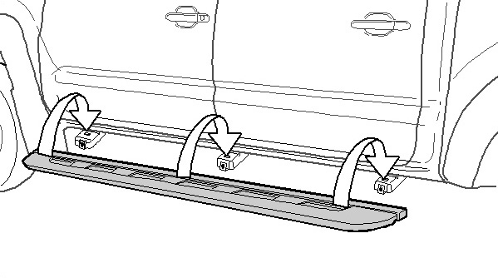

Fig. 1-3

caution_2**NOTE:** The first mounting hole from the front of the running board is used for the front bracket.

* 1. caution_2By hand, place M6 bolts UP through the brackets into the threaded holes in the running board (Fig. 1-4). Start with the front position.

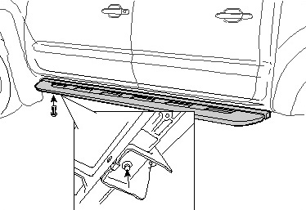

Fig. 1-4

* 1. By hand, place M6 bolts through the running board into the clips on the brackets (Fig. 1-5).

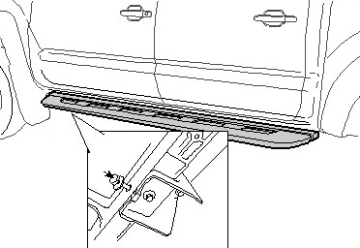

Fig. 1-5

* 1. Torque all the UP M6 bolts to 10 N-m first.

**Torque: 10 N-m (7 ft-lbf)**

* 1. Torque the horizontal M6 bolts to 10 N-m next.

**Torque: 10 N-m (7 ft-lbf)**

* 1. Torque the outer M8 bolts to 22.5 N-m first.

##### Torque: 22.5 N-m (17 ft-lbf)

* 1. Torque the inner M8 bolts to 22.5 N-m next.

##### Torque: 22.5 N-m (17 ft-lbf)

##### Install the Right Side Running Board.

* 1. Repeat Step 1 on the right side.
  2. Torque all the UP M6 bolts to 10 N-m first.

**Torque: 10 N-m (7 ft-lbf)**

* 1. Torque the horizontal M6 bolts to 10 N-m next.

**Torque: 10 N-m (7 ft-lbf)**

* 1. Torque the outer M8 bolts to 22.5 N-m first.

##### Torque: 22.5 N-m (17 ft-lbf)

* 1. Torque the inner M8 bolts to 22.5 N-m next.

**Torque: 22.5 N-m (17 ft-lbf)**

##### Complete the Install.

* 1. Re-torque all of the bolts.
  2. Torque all M6 bolts to 10 N-m.

**Torque: 10 N-m (7 ft-lbf)**

* 1. Torque all M8 hardware to 22.5 N-m.

##### Torque: 22.5 N-m (17 ft-lbf)

* 1. **PPO Only:** Complete the torque audit sheet within five minutes of the installation.

Accessory Function Checks

Running board alignment

Inspect bolt torques

Vehicle Function Checks

Ensure the running board is centered on the vehicle

Complete the torque audit sheet within five minutes of the installation

Vehicle Appearance Check

After accessory installation and removal of protective cover(s), perform a visual inspection.

Ensure no damage (including scuffs and scratches) was caused during the installation process.

(For PPO installations, refer to TMS Accessory Quality Shipping Standard.)